Class overview

2 students High potential / gifted.
- 1 2E student (Gifted & ADHD)
- 6 students on a substantial IEP - social/emotional & cognitive

Pre assessment data
8 Ss have below Stage 1 knowledge of halving
13 Ss have core knowledge of halving but need further work to explain understanding.
10 students have thorough knowledge of how to halve, these students need to develop skills in applying this knowledge.

2 HPGE ss can work as a good partnership but teacher must check in. They do need explaining before a task is started.
Core work well as a whole group with hands on activities.
Support students need teacher’s aide to begin most activities.

Class works well with hands on activities and enjoys show me boards to display learning.

Exploring halves – 20 minutes - Taken from Year A, Unit 5 https://education.nsw.gov.au/teaching-and-learning/curriculum/mathematics/planning-programming-and-assessing-mathematics-k-6/mathematics-k-2-units#Stage3
This activity has been adapted from Paper halving parts 1 (11:58) and 2 (13:46) from Thinking mathematically.
1. Display Resource 11: Examples of halves. Ask students what they notice, what is the same, and what is different about the images.
2. Provide individual thinking time before students turn and talk.
While core are doing this, teacher explains the following task to the HPGE & students who have shown competency in this area.
- Students are shown simple images of halves. Ask them to find four different ways to halve a piece of paper using a ruler & pencil.
- Ss are given varied shapes & asked to find the half & quarter of each of these.
- Ss are given images of different countries' flags. Which flags can be divided into halves or quarters and show the same colours on each part? Different images in each part?
3. Strategically select students to share their thinking with the class. Ask:
· What do you notice about the images?
· Is there something in common between the images?
· What are some things you already know about halves?
· Do all the halves look the same?
Note: Highlight that halves can look different, but still be a half because the whole was divided (shared) into 2 equal parts.
4. Provide each student with a piece of A4 paper. Ask students what 2D shape the paper is and then try to halve their piece of paper.
5. Students share how they halved their paper. Highlight how there are many ways that a piece of paper can be halved: horizontally, vertically, diagonally, and so on (see Figure 8). Challenge students to identify the different 2D shapes they created when halving their piece of paper.
Figure 8 – Paper halves
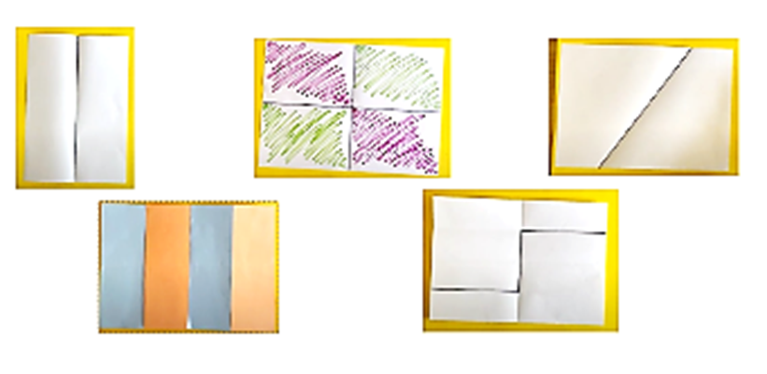
6. Provide pairs of students with A4 paper and pencils to demonstrate different ways to halve a piece of paper. Students can fold or use pencils to indicate different halves.
Challenge students to identify and record the different 2D shapes they created whilst halving the pieces of paper

Check in with HPGE students when core task is at work

Proving halves – 20 minutes
1. Provide pairs of students with a range of materials. Students use informal units to cover the surface of each half to prove they have created equal halves.
2. Students sort their pieces of paper into equal halves and not equal halves.
3. As a class, students demonstrate and share the way they proved their paper was divided into 2 equal halves.
Note: Take photographs of how students have sorted their halves.
The table below details assessment opportunities and differentiation ideas.
Assessment opportunities | Too hard? | Too easy?
What to look for:  · Can students accurately halve a piece of paper? (MAO-WM-01, MA1-2DS-01, MA1-2DS-02)  · Are students able to identify different ways to halve a piece of paper? (MAO-WM-01, MA1-2DS-01, MA1-2DS-02)  · Can students use materials to check they have created equal halves? (MAO-WM-01, MA1-2DS-02)  What to collect:  · photographs of student work. (MAO-WM-01, MA1-2DS-01, MA1-2DS-02) | Students are not confident halving a piece of paper.  · Have students tell you anything they know about halves. Encourage links between their knowledge and halving a piece of paper. Model one way to halve the paper and ask them if they have another way to halve it.  · Provide students with a circular piece of paper, as half always looks the same. | Students confidently halve A4 paper in a range of ways.  · Prompt students to think of other ways to halve an object using more than one fold line (see Figure 8).  · Provide a piece of paper that has been halved in a complex way and ask the student to prove or disprove whether the paper has been halved.

